**Folder Structure (**Screenshot)**:**

**Link to Folder:** [tobilobasalawu/digitalportfolio (github.com)](https://github.com/tobilobasalawu/digitalportfolio)

There 4 different folders used to organize the files in an appropriate format. As a result of using GitHub, the CSS stylesheet and HTML pages are stored in the main folder so that the pages on the site can be displayed directly without adding any extra text or characters to the URLs (Permalink). The image folder stores all images used in the site with a subfolder containing those used in the tech stack section. While the components and JS folder stores the JavaScript used for the site, and the assets folder stores all the unit resources (tasks & assignments).

**Main Folder:**

**Images Folder:**

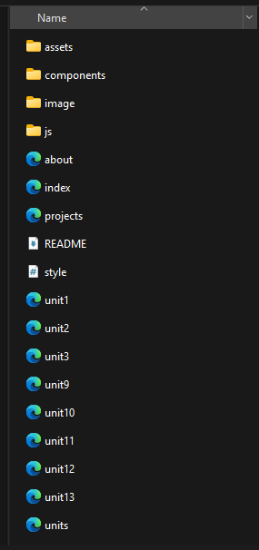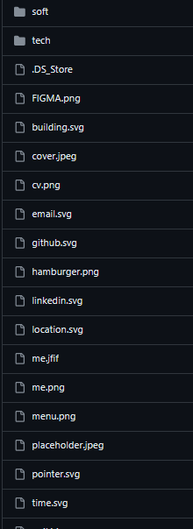

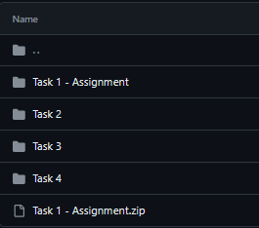

**Assets Folder:**

**Components Folder:**

**JS Folder:**

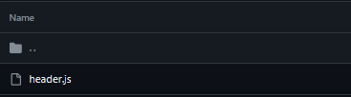

**Test Plan:**

|  |  |  |  |  |  |
| --- | --- | --- | --- | --- | --- |
| Name of portfolio: | | [Portfolio (tobilobasalawu.github.io)](https://tobilobasalawu.github.io/digitalportfolio/) | | | |
| Date of testing: | | 12/05/2024 | | | |
| Name of tester: | | Tobi Salawu | | | |
| No. | Test description | | Expected outcome | Actual outcome | Comments |
| 1 | To test if the “Home” hyperlink on the menu takes you to the homepage. | | Upon clicking the “Home” hyperlink on the menu, the homepage should open. | Upon clicking the “Home” hyperlink, the homepage opened as expected. | Success. |
| 2 | To test if the “About” hyperlink on the menu navigates to the homepage. | | Upon clicking the “About” hyperlink on the menu, the about page should open. | Upon clicking the “About” hyperlink, the about page opened as expected. | Success. |
| 3 | To test if the dropdown links under the academics ‘LEVEL 2 IT WORK’ takes you the unit’s page. | | Upon hovering over “Academics” hyperlink on the menu, the Level 2 IT work should be displayed. | Upon hovering over “Academics” hyperlink on the menu, the Level 2 IT work links were displayed and the page displayed the units opened as expected | Success. |
| 4 | To test if any of the unit’s links under the ‘LEVEL 2 IT WORK’ are displayed and users can navigate to the page(hyperlink) | | Upon hovering over ‘LEVEL 2 IT WORK’, the units (links under it) should be displayed and each page can be opened directly from it. | The links were displayed and each page opened as expected. | Success. |
| 5 | To test if the “projects” hyperlink on the menu navigates to the projects page. | | Upon clicking the “projects” hyperlink on the menu, the project page should be open. | The projects page opened as expected when clicked. | Success. |
| 6 | To verify that the social media links work. | | Upon clicking on the social media icons, user should navigate to the social media site. | The social media links work as expected. | Success. |
| 7 | To test if the email address link displayed on the about page description functions. | | When Clicked users should be directed to their mail | The mail address link works as expected. | Success |
| 8 | To verify if the button ‘Learn more’ on the homepage navigates to the project page. | | Upon clicking on the ‘learn more’ button, the site should navigate tot the projects page | After clicking on the ‘Learn more’ button, the site navigates to the projects page as expected | Success |
| 9 | To test the download function of tasks listed under the resources (Assignment & Tasks) section on each unit page of the ‘LEVEL 2 IT WORK’. | | The files should be successfully downloaded whenever the tasks listed are clicked | The download function has been tested and the tasks successfully downloads when clicked. | Success.  (Expect Pending tasks) |
| 10 | To test if the Unit 1: Online World page can be opened | | Whenever the hyperlink is clicked, the site should navigate to the page. | The page opens as expected when the hyperlink is clicked. | Success |
| 11 | To test if the Unit 2: Technology System page can be opened | | Whenever the hyperlink is clicked, the site should navigate to the page. | The page opens as expected when the hyperlink is clicked. | Success |
| 12 | To test if the Unit 3: Digital Portfolio page can be opened | | Whenever the hyperlink is clicked, the site should navigate to the page. | The page opens as expected when the hyperlink is clicked. | Success |
| 13. | To test if the Unit 9: Spreadsheet Development page can be opened | | Whenever the hyperlink is clicked, the site should navigate to the page. | The page opens as expected when the hyperlink is clicked. | Success |
| 14. | To test if the Unit 10: Database Development page can be opened | | Whenever the hyperlink is clicked, the site should navigate to the page. | The page opens as expected when the hyperlink is clicked. | Success |
| 15. | To test if the Unit 11: Computer Networks page can be opened | | Whenever the hyperlink is clicked, the site should navigate to the page. | The page opens as expected when the hyperlink is clicked. | Success |
| 16. | To test if the Unit 12: Software Development page can be opened | | Whenever the hyperlink is clicked, the site should navigate to the page. | The page opens as expected when the hyperlink is clicked. | Success |
| 17. | To test if the Unit 13: Website Development page can be opened | | Whenever the hyperlink is clicked, the site should navigate to the page. | The page opens as expected when the hyperlink is clicked. | Success |

**User Feedback:**

|  |  |  |  |
| --- | --- | --- | --- |
| User feedback form for digital portfolio | | | |
| Name of user: Isaac Eric | | | |
| Question number | Question | Response | Actions/notes |
| 1 | How clear are the images? | The images are clear and they are all displayed with high quality in a compatible format.  Although an image was missing causing it display an empty box in the unit’s section | The image has been removed.  Before and after screenshot of the test is displayed below. |
| 2 | Can you get to the first page easily? | Yes, I can navigate to the first page easily. It’s either by clicking on the logo or clicking on the ‘Home’ hyperlink on the menu bar. |  |
| 3 | How can you tell which page you are on? Is it clear? | Each page contains a title and a description of on its content. |  |
| 4 | Was the size of text easy to read? | The size of the text is bold making it easy for me and other users to read. | The text is bold in general. However, most browsers contain zoom option to support users with visibility issues. |
| 5 | Has the spelling and grammar been checked? | Few grammar errors were present. | The errors have been corrected. |
| 6 | Are you able to get information on the tasks students completed? | Yes, each task for the assignment contains a description and a link to download a each. Although, I noticed that most of tasks were pending. | The course is still in progress, but I would make sure that each task are uploaded right after the units are completed. |
| 7 | Are you able to tell who made or owns the website | Yes, the website contains an about page with a brief information on the owner. The homepage also displays a headline stating the student’s name and image. |  |
| 8 | Has the person stated what they are studying at the moment | Yes, the about page also contains a description on what he is studying and currently working on. |  |
| 9 | Are the internal links working? | All internal links are working and functioning properly. |  |
| 10 | Are the external links working? | Just like the internal links, all external links are working and functioning properly without any issues. |  |
| 11 | What I liked | I liked the website in general, the colour scheme was well chosen. The navigation on the website is smooth and easy, so it is simple to find any information and understand the content |  |
| 12 | Areas for improvement | An image in the unit 3 page was missing causing it to display an empty box.  The title ‘Resources (Assignments & Tasks) on each of the units page was overlapping on the unit description’s paragraph | All Errors have been fixed, a screenshot of before and after the change have been displayed before |

**Area of Improvements:**

1. For the missing image displaying an empty box on unit 3: Digital portfolio.

**Before Change: After Change:**

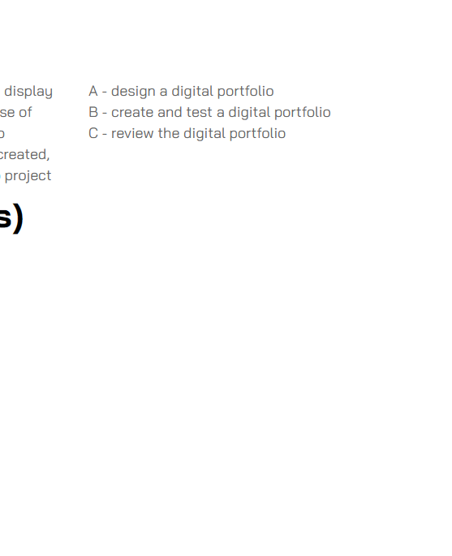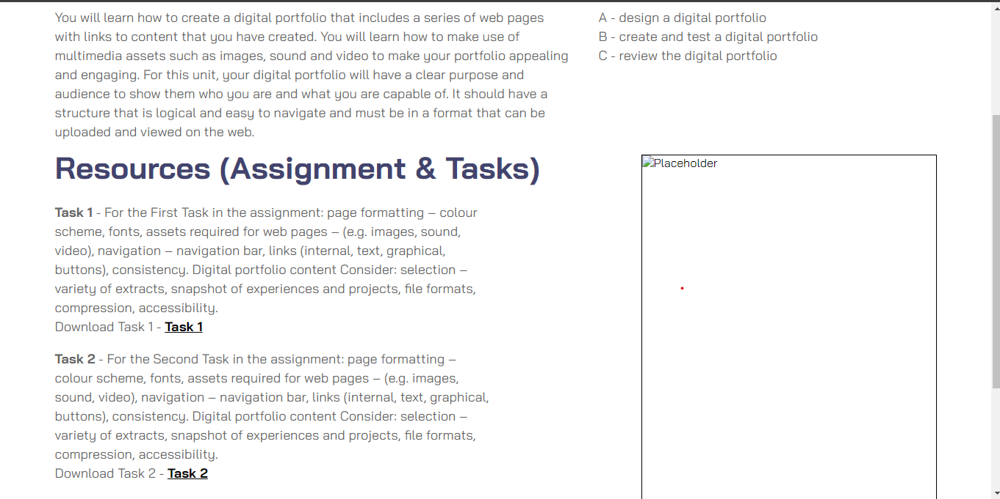

1. For the title ‘Resources (Assignments & Tasks) on each of the unit’s page overlapping on the unit description’s paragraph.

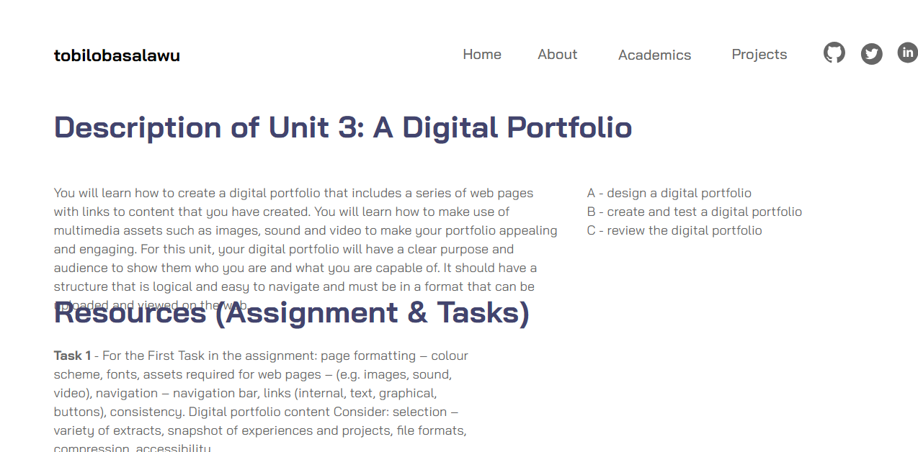**Before Change:**

**After Change:**

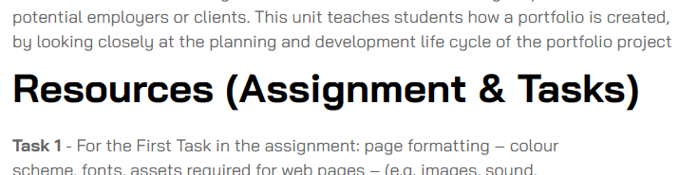

**Refining and justifying choice of content:**

The folder structure organizes files to ensure that the content of the site can be easily accessed and maintained. The test plan checks out everything part of the site so as to ensure usability and reliability. Feedback helps point out problem making the creator(me☺) to make improvements. By making improvements, it shows the steps taken to meet the user requirements and the portfolio’s intended purpose. With all this, I think the portfolio’s content and choices made are all about easy navigation, solving issues and making improvements.